SQL Assignment 4.
Q1. Create a database named company and a table named employees with the following fields:
- id (INT, Primary Key, Auto Increment)
- name (VARCHAR (100))
- position (VARCHAR (100))
- salary (DECIMAL (10,2))
- date_of_joining (DATE)
code:
create database companyy;
use companyy;
create table employees(
id INT Primary Key,
name varchar(100),
position varchar(100),
salary DECIMAL(10,2),
date_of_joining DATE);

Q2. Insert the following data into the employees table:
- John Doe, Manager, 55000.00, 2020-01-15
- Jane Smith, Developer, 48000.00, 2019-07-10
- Alice Johnson, Designer, 45000.00, 2021-03-22
- Bob Brown, Developer, 50000.00, 2018-11-01

Code:
INSERT INTO employees (id, name, position, salary, date_of_joining ) VALUES
(1, "John Doe", "Manager", 55000.00, "2020-01-15"),
(2, "Jane Smith", "Developer", 48000.00, "2019-07-10"),
(3, "Alice Johnson", "Designer",45000.00, "2021-03-22"),
(4, "Bob Brown", "Developer", 50000.00, "2018-11-01");
select * from employees;
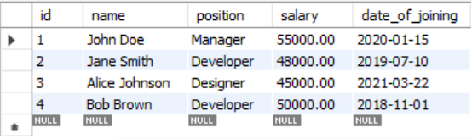

Q3. Write a query to retrieve all employees who are Developers.

select * from employees
where position = "Developer";
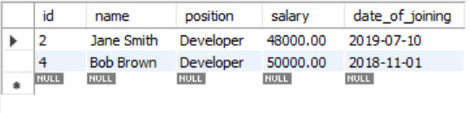

Q4. Write a query to update the salary of Alice Johnson to 46000.00.
set sql_safe_updates=0;
UPDATE Employees
SET Salary = 46000.00
WHERE Name = 'Alice Johnson';
select * from employees;
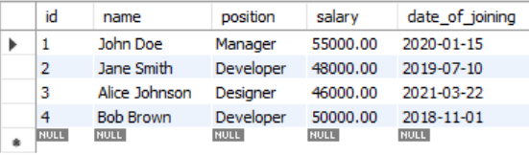

Q5. Write a query to delete the employee record for Bob Brown.
DELETE FROM Employees
WHERE Name = 'Bob Brown';
select * from employees;
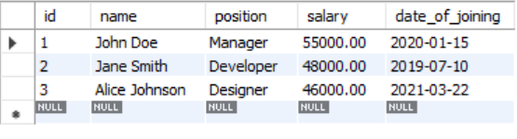

Q6. Write a query to find the employees who have a salary greater than 48000.
select * from employees
where salary>48000;
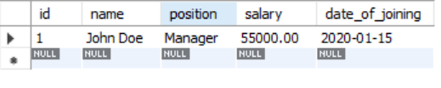

Q7. Write a query to add a new column email to the employees table.
alter table employees add email varchar(20);
select * from employees;
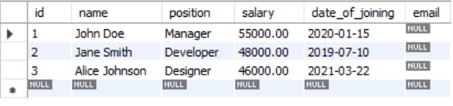

Q8. Write a query to update the email for John Doe to john.doe@company.com.
UPDATE Employees
SET email = "john.doe@company.com"
WHERE Name = "John Doe";
select * from employees;
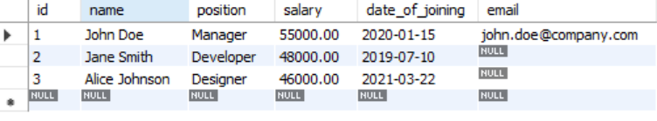

Q9. Write a query to retrieve only the name and salary of all employees.
SELECT Name, Salary
FROM Employees;
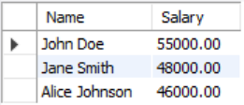

Q10. Write a query to count the number of employees who joined after January 1, 2020.

SELECT COUNT(*) AS employee_count
FROM employees
WHERE date_of_joining > '2020-01-01';
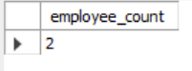

Q11. Write a query to order the employees by salary in descending order.
SELECT * FROM employees
ORDER BY salary DESC;
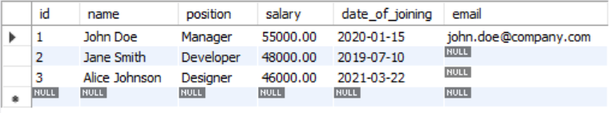

Q12. Write a query to drop the email column from the employees table.
ALTER TABLE employees
DROP COLUMN email;
select * from employees;
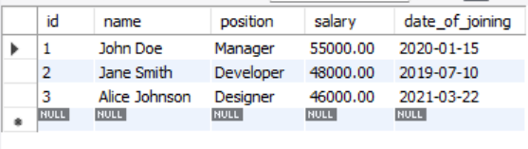

Q13. Write a query to find the employee with the highest salary.

SELECT * FROM employees
WHERE salary = (SELECT MAX(salary) FROM employees);
